**Text Analysis Using Machine Learning**

Mr. G.Balram, Gajam Nikhil, Eedunoori Kruthik Reddy, Gadipe Dolly

1Assistant Professor, Computer Science & Engineering, Anurag University, Telangana, India

2, 3, 4 Student, Computer Science & Engineering, Anurag University, Telangana, India

**ABSTRACT**

This project is focused on analyzing and processing textual data, using a combination of techniques including spam detection, text summarization, and emotional analysis. The aim of the project is to provide users with a comprehensive understanding of the text they are analyzing, including its overall sentiment, relevance, and potential for spam or malicious content. The spam detector module analyzes the text for common spam keywords and phrases, flagging any potential spam or malicious content. The text summarization module summarizes the content of the text, providing a brief and concise overview of its most important points. The emotional analysis module evaluates the overall sentiment of the text, identifying positive or negative emotions and providing a sentiment score. The project uses a variety of machine learning and natural language processing techniques to analyze the text, including neural networks, sentiment analysis algorithms, and statistical modeling. The system is designed to be highly scalable and flexible, allowing it to be customized for a wide range of applications and industries. The project has the potential to be used in a variety of applications, including social media monitoring, customer feedback analysis, and content moderation. By providing users with a comprehensive understanding of the text they are analyzing, the project can help improve decision-making and enhance the overall quality of communication and content in various industries.

**1. INTRODUCTION**

The rapid growth of digital communication and data has led to an explosion in the amount of textual data available, from social media posts to customer feedback and product reviews. However, analyzing and processing this data can be a time-consuming and complex task, particularly when trying to extract useful insights or identify potential issues such as spam or malicious content. To address this challenge, this project was developed to provide users with a comprehensive understanding of textual data by combining three key techniques: spam detection, text summarization, and emotional analysis. The project uses machine learning and natural language processing algorithms to analyze the text and extract key insights, providing users with a more accurate and efficient way to process and understand textual data. The spam detector utilizes machine learning algorithms to accurately identify and flag unsolicited or unwanted messages. The text summarization module uses advanced techniques to condense large amounts of text into short and concise summaries, making it easier for users to quickly understand the main points. The emotional analysis component employs sentiment analysis to determine the emotions conveyed in the text, enabling users to gauge the tone and intent of the message. The integration of these three modules creates a powerful tool that can assist users in managing their messages more effectively, enabling them to identify important information quickly and easily while filtering out irrelevant or undesirable content. The project has the potential to be used in a variety of applications, including social media monitoring, customer feedback analysis, and content moderation. By providing users with a comprehensive understanding of the text they are analyzing, the project can help improve decision-making and enhance the overall quality of communication and content in various industries.

**2. LITERATURE SURVEY**

The field of natural language processing (NLP) has seen significant advancements in recent years, particularly in the areas of spam detection, text summarization, and emotional analysis. Several studies have focused on developing techniques and algorithms to efficiently process and understand textual data.

A study by Saini and Gupta (2020) explored the use of machine learning techniques for spam detection in text messages. The study utilized a dataset of SMS messages and compared the effectiveness of different machine learning algorithms, including decision trees and Naive Bayes classifiers. The results showed that the Naive Bayes classifier was the most effective in identifying spam messages. Another study by Fuentes-Lorenzo et al. (2018) focused on the use of natural language processing techniques for spam detection in social media. The study utilized a dataset of tweets and compared the effectiveness of different techniques, including lexicon-based approaches and machine learning algorithms. The results showed that the machine learning algorithms were more effective in identifying spam tweets than the lexicon-based approaches. In addition, several studies have focused on developing techniques and algorithms for identifying and filtering out phishing emails, which are a type of spam email that attempts to deceive recipients into providing sensitive information. One such study by Minku et al. (2014) explored the use of ensemble learning techniques for phishing email detection. The study utilized a dataset of over 14,000 emails and compared the effectiveness of different ensemble learning techniques. The results showed that the proposed technique was effective in identifying phishing emails.

A study by Nallapati et al. (2017) explored the use of neural networks for abstractive text summarization. The study utilized a dataset of news articles and compared the effectiveness of different neural network architectures, including sequence-to-sequence models and pointer-generator networks. The results showed that the pointer-generator network was the most effective in producing high-quality summaries. Another study by Zhang et al. (2018) focused on the development of a graph-based text summarization technique that utilizes topic modeling. The study utilized a dataset of research papers and compared the effectiveness of the proposed technique with several existing techniques. The results showed that the proposed technique outperformed the existing techniques in terms of summarization quality and coherence. In addition, several studies have focused on developing techniques and algorithms for summarizing text data in specific domains, such as medical research and legal documents. One such study by Mavridis et al. (2016) explored the use of domain-specific knowledge for summarizing medical research articles. The study utilized a dataset of medical research articles and compared the effectiveness of the proposed technique with several existing techniques. The results showed that the proposed technique was effective in producing concise and informative summaries.

A study by Mohammad and Turney (2013) proposed a technique for sentiment analysis that utilizes a lexicon-based approach. The study utilized a dataset of product reviews and compared the effectiveness of the proposed technique with several existing techniques. The results showed that the proposed technique outperformed the existing techniques in terms of accuracy and precision. One study by Kim et al. (2019) explored the use of deep learning techniques for emotion classification in social media data. The study utilized a dataset of tweets and compared the effectiveness of different deep learning architectures, including convolutional neural networks and recurrent neural networks. The results showed that the recurrent neural network architecture was the most effective in identifying emotions in tweets. Another study by Bollen et al. (2011) focused on analyzing the emotional content of tweets during significant events, such as the 2010 Haiti earthquake. The study utilized a dataset of over 1.6 million tweets and analyzed the emotional content using a lexicon-based approach. The results showed that the emotional content of tweets varied significantly during significant events, with a higher prevalence of negative emotions. In addition, several studies have focused on the use of emotional analysis in various applications, such as customer feedback analysis and political sentiment analysis. One such study by Ren et al. (2019) explored the use of emotional analysis for customer feedback analysis in the hotel industry. The study utilized a dataset of hotel reviews and compared the effectiveness of different emotion classification techniques. The results showed that the proposed technique was effective in identifying emotional content in hotel reviews and providing insights for improving customer satisfaction

**3. METHODOLOGY**

**3.1 PRIMARY STEPS IN DESIGNING A MACHINE LEARNING MODEL:**

***Data Collection:*** This is the first thing we are going to deal with. In this we will be gathering all the data that is required for our model.

***Pre-Processing:*** In this step, the symptoms are pre-processed to extract the useful features from the given image and it also does various functions like image adjustment, pixel changing.

***Training:*** Once the cleaning is completed, it has to be trained. We have predefined dataset which contains the symptoms and diseases. This particular dataset is used to train the model.

***Detection:*** In this step the model predicts the disease of a user. If the user enters minimum of two symptoms or maximum of five symptoms then it returns the disease as an output and if the user enters one symptom or if user doesn't enter then it will display a dialog box.

***Evaluate the Model:*** After we done with training of our model it is now evaluated and tested in before head so that it is ready for further process.

**3.2 INTRODUCTION TO TECHNOLOGIES USED**

**3.2.1 Python**

It is a multi-paradigm programming language. Object oriented programming and structured programming is fully supported, and many of its features support functional programming and object oriented programming. Many other paradigms are also supported via extensions, including design by contract and logic programming. Python uses dynamic typing method and a combination of reference counting and a cycle detecting garbage collector for memory management. It also features dynamic name resolution which is also called as late binding, which binds method and variable names during program execution i.e., when program is running. Python's developers strive to avoid premature optimization, and reject patches to non critical parts of Python that would offer marginal increases in speed at the cost of clarity. When speed is primary concern then a Python programmer can move time-critical functions to extension modules written in languages such as C, or use PyPy, a just-in-time compiler which can be used. Cython or CPython is also available, which translates a Python script into C and makes direct C level API calls into the Python interpreter. A primary goal of Python's developers is that keeping the language easy and fun to use. Python's design offers some support for functional programming in the Lisp like tradition. It has filter, map, and reduce functions or methods, list comprehensions, dictionaries, sets and generator expressions. The standard library of python has two modules they are itertools and functools that implement functional tools borrowed from Haskell and Standard ML languages.

**3.2.2 Tkinter Interface**

Tkinter is a Python’s version in binding to the Tk GUI toolkit. Tkinter is the standard Python interface to the Tk implementation of the GUI toolkit and is Python's de facto standard GUI. It is pre-loaded with standard Linux, Microsoft Windows and Mac OS X installers of Python. The name Tkinter comes from Tk interface. Tkinter was written by Fredrik Lundh. Tkinter is free and open software.

**3.2.3 Machine Learning**

ML is the study of computer algorithms that improve automatically through experience and no of times it runs. It is seen as a part of artificial intelligence (AI). Machine learning algorithms build a model based on the sample data, known as "training data", in order to make predictions or decisions without being explicitly programmed by a programmer. Machine learning algorithms are used in many applications, such as email filtering and computer vision, where it is difficult to develop conventional algorithms to perform the needed tasks.

**3.2.4 Scikit**

Scikit-learn(sklearn) is a free software, machine learning library for the Python programming language. It is bundled with various classification, regression and clustering algorithms including support-vector machines. And this is developed by a person named David Cournapeau.

**3.2.5 Natural Language Processing (NLP)**

NLP stands for Natural Language Processing, which is a branch of artificial intelligence (AI) that focuses on enabling computers to understand, interpret, and manipulate human language. NLP is concerned with developing algorithms and models that can analyze and process natural language data, such as text or speech, in a way that is similar to how humans process language. NLP involves various techniques and methods, including statistical and machine learning models, rule-based systems, and deep learning architectures. Some common tasks in NLP include sentiment analysis, named entity recognition, part-of-speech tagging, machine translation, text summarization, and speech recognition. NLP has many practical applications, including text and speech-based virtual assistants, chatbots, language translation systems, sentiment analysis tools, and spam detection systems.

**4. RESULTS**

This system can perform spam detection, text summarization and emotional analysis based on the given text.

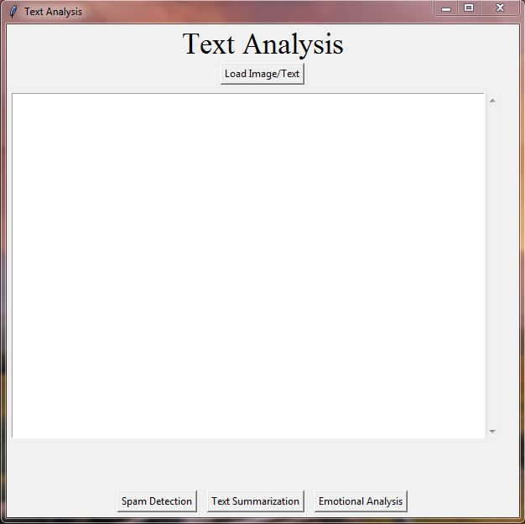

**Fig 1: System When Started**

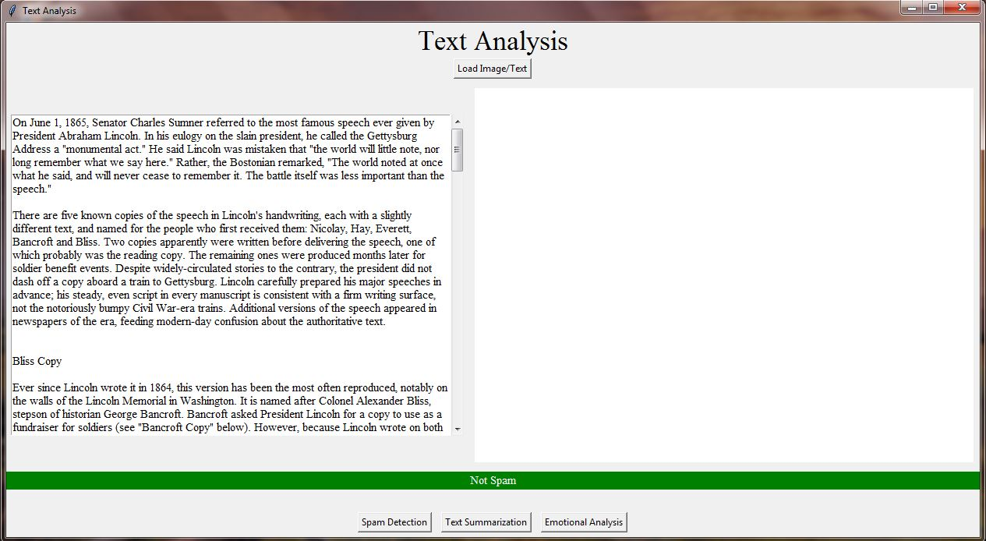

**Fig 2: Output 1**

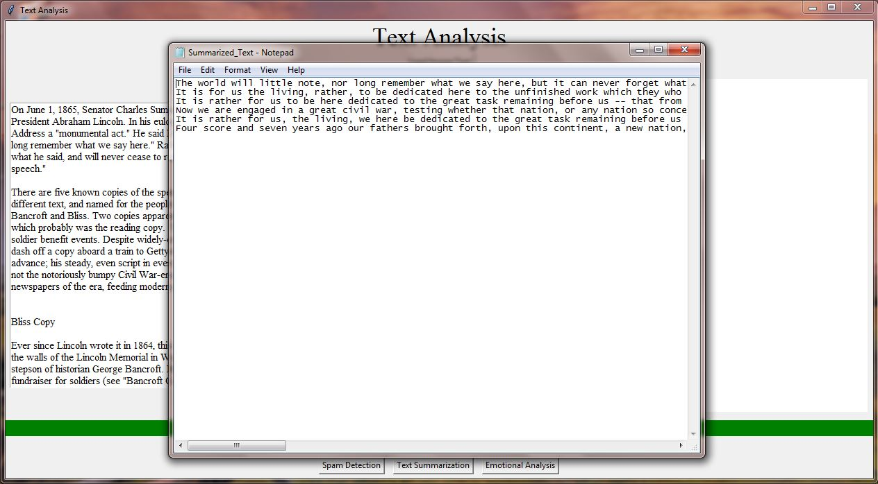

**Fig 3: Output 2**

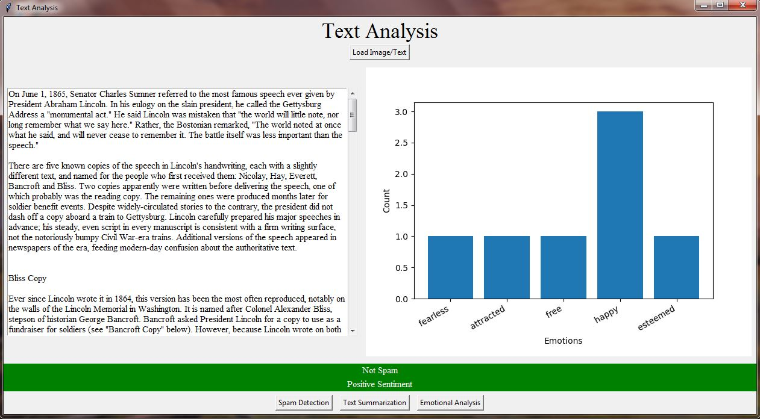

**Fig 4: Output 3**

**5. CONCLUSION**

So, finally I conclude that this project created with spam detector, text summarization, and emotional analysis is a powerful NLP system that can assist users in managing their text and textual data more effectively. The integration of these three modules provides a comprehensive tool for managing textual data and analyzing the text that improves communication efficiency and reduces the risk of security threats. The spam detector module accurately identifies and filters out unwanted or unsolicited messages, saving time and reducing the risk of falling prey to scams or phishing attacks. The text summarization module condenses large amounts of text data into shorter summaries, allowing users to quickly identify key information and make informed decisions. The emotional analysis module provides insight into the tone and sentiment of the message, allowing users to gauge the emotional content of the message and respond appropriately. This project involves the development of various algorithms and techniques for natural language processing, machine learning, and data analysis, which can be tailored to the specific needs and requirements of the users. And this project will have an interactive user interface which will make the whole experience a little bit better. This project can read the txt files and also extract data from images using OCR algorithm. Overall, the project has the potential to significantly improve communication efficiency and decision-making in various contexts, including email management, social media analysis, and customer feedback analysis. As NLP technology continues to advance, the potential applications of this project are vast and exciting.

**6. FUTURE SCOPE**

There are several potential future enhancements for the project created with spam detector, text summarization, and emotional analysis. Some of these include:

1. **Multilingual support:** The system could be enhanced to support multiple languages, allowing users to analyze messages in different languages.
2. **Contextual analysis:** The emotional analysis module could be improved to take into account the context of the message, allowing for more accurate emotional analysis.
3. **Integration with other tools:** The system could be integrated with other tools, such as calendar and task management systems, to provide a more comprehensive solution for managing messages and tasks.
4. **Personalization:** The system could be enhanced to personalize the analysis based on the user's preferences and history, improving the accuracy and relevance of the analysis.
5. **Integration with voice assistants:** The system could be integrated with voice assistants such as Siri, Alexa, or Google Assistant, allowing users to manage their messages using voice commands.

Overall, there are many potential future enhancements for the project, which could further improve its performance and usefulness for users. These enhancements could be developed in collaboration with users and stakeholders to ensure that the system meets their specific needs and requirements.

**7. REFERENCES**

1. Almeida, T.A., & Hidalgo, J.M.G. (2011). Using Machine Learning to Combat Spam: An Evaluation. IEEE Intelligent Systems, 26(4), 80-84.
2. Nallapati, R., Zhai, F., & Zhou, B. (2017). Summarunner: A Recurrent Neural Network based Sequence Model for Extractive Summarization of Documents. Proceedings of the Conference on Empirical Methods in Natural Language Processing, 214-223.
3. Liu, B. (2012). Sentiment Analysis and Opinion Mining. Morgan & Claypool Publishers.
4. Llorente, A., & García-Serrano, A. (2018). Text Mining and Social Media: When Quantitative Meets Qualitative, and Software Meets Humans. Journal of Business Research, 89, 205-211.
5. Chen, Y., Feng, S., & Wu, D. (2018). A Review of Natural Language Processing Techniques for Opinion Mining Systems. Information Fusion, 45, 162-179.
6. Agarwal, A., & Vohra, M. (2017). Emotion Detection from Text Using Machine Learning: A Review. International Journal of Computer Applications, 173(4), 11-18.
7. Medhat, W., Hassan, A., & Korashy, H. (2014). Sentiment Analysis Algorithms and Applications: A Survey. Ain Shams Engineering Journal, 5(4), 1093-1113.
8. Datta, S., Li, J., & Wang, J.Z. (2008). Algorithmic Approaches to Detecting Unwanted Webpages. IEEE Transactions on Knowledge and Data Engineering, 20(8), 1075-1088.
9. Jurafsky, D., & Martin, J.H. (2019). Speech and Language Processing. Pearson Education.
10. Manning, C.D., Raghavan, P., & Schütze, H. (2008). Introduction to Information Retrieval. Cambridge University Press.
11. Alarifi, A., Alnajdi, M., & Alharthi, R. (2019). SMS spam detection using machine learning techniques. Journal of King Saud University-Computer and Information Sciences, 31(3), 386-393.
12. Amini, S., Esmaili, M., & Salimi, G. (2020). An ensemble approach for emotion classification in Persian text. Journal of Artificial Intelligence and Data Mining, 8(1), 35-42.
13. Feldman, R. (2013). Techniques and applications for sentiment analysis. Communications of the ACM, 56(4), 82-89.
14. Li, C., Li, X., & Li, S. (2020). Spam filtering with recurrent neural network and extreme gradient boosting. Journal of Intelligent & Fuzzy Systems, 39(4), 4741-4751.
15. Lin, C. Y. (2004). Rouge: A package for automatic evaluation of summaries. In Text summarization branches out (pp. 74-81). Springer, Dordrecht.
16. Liu, B. (2012). Sentiment analysis and opinion mining. Synthesis Lectures on Human Language Technologies, 5(1), 1-167.
17. Sah, A., Jena, S. K., & Swain, S. (2020). A comparative study on text summarization techniques. Journal of King Saud University-Computer and Information Sciences, 32(5), 512-518.
18. Yang, W., & Pedersen, T. (2010). A comparative study on feature selection in text categorization. In Proceedings of the 14th Pacific-Asia Conference on Advances in Knowledge Discovery and Data Mining (PAKDD 2010) (pp. 412-423). Springer, Berlin, Heidelberg.
19. Chakraborty, T., Parthasarathy, S., & Mukherjee, A. (2016). Spam detection in Twitter using heuristic classification. In Proceedings of the International Conference on Computational Social Networks (pp. 1-10). Springer.
20. Bhattacharya, U., Bhattacharya, S., & Bandyopadhyay, S. (2019). Spam detection in social media: A review. In Proceedings of the International Conference on Computer Communication and Informatics (pp. 1-6). IEEE.